Appendix 1. Ecosystem and Socioeconomic Profile of the Snow Crab stock in the Bering Sea Report Card

Erin Fedewa, Kalei Shotwell, Abby Tyrell

Draft 2023



*With Contributions from:*

Kalei Shotwell, Abby Tyrell

# Current Year Update

The ecosystem and socioeconomic profile, or ESP, is a standardized framework for compiling and evaluating relevant stock-specific ecosystem and socioeconomic indicators and communicating linkages and potential drivers of the stock within the stock assessment process (Shotwell et al., 2023). The ESP process creates a traceable pathway from the initial development of indicators to management advice and serves as an on-ramp for developing ecosystem-linked stock assessments.

Please refer to the last full ESP, partial, and report card documents (*list references*) which are available within the Snow Crab stock assessment and fishery evaluation or SAFE reports for further information regarding the ecosystem and socioeconomic linkages for this stock.

## Management Considerations

Summary conclusions from ESP for ABC (risk table)

## Modeling Considerations

Summary of indicators with high importance in the Bayesian adaptive sampling routine and discussion of which indicators have had consistent high importance. List of research ecosystem model runs that are currently ongoing and potential for operational use in the future.

# Assessment

## Ecosystem and Socioeconomic Processes

One paragraph description of ecosystem and socioeconomic (if available) conceptual model(s)

## Indicator Suite

One paragraph description of LME level indicators relevant to stock (ESR summary)

### Ecosystem Indicators:

#### 1. Larval Indicators

1. AMJ_Chlorophylla_Biomass_SEBS_Satellite: Derived chlorophyll a concentration during spring and summer season (April, May, June) in the northern middle southeastern Bering Sea from the MODIS satellite
   * Contact: Matt Callahan
   * Status and trends: Low this year
   * Factors influencing trends: Larval growth and survival is dependent on high concentrations of diatoms (Paul et al., 1979)
   * Implications: **Information not present in database**
2. Winter_Spring_Arctic_Oscillation_Index_Model: Winter-spring Arctic Oscillation index from the NOAA National Climate Data Center
   * Contact: Erin Fedewa
   * Status and trends: TBD
   * Factors influencing trends: Poor crab recruitment is associated with positive values of the Arctic Oscillation
   * Implications: **Information not present in database**

#### 2. Juvenile Indicators

1. Summer_Cold_Pool_SEBS_Survey: The areal extent of EBS bottom trawl survey stations with bottom temperatures < 2 degrees C
   * Contact: Erin Fedewa
   * Status and trends: TBD
   * Factors influencing trends: The cold pool provides predator refuge for juvenile snow crab and cold water habitat availability (< 2°C) has been proposed as a critical recruitment bottleneck (Dionne et al., 2003; Parada et al., 2010)
   * Implications: **Information not present in database**
2. Summer_Snow_Crab_Juvenile_Temperature_Occupancy: Mean bottom temperature weighted by immature female snow crab CPUE at each station of the EBS summer bottom trawl survey
   * Contact: Erin Fedewa
   * Status and trends: TBD
   * Factors influencing trends: Immature snow crab are highly sensitive to bottom temperatures and 2°C is an important maximum temperature threshold (Dionne et al., 2003; Murphy 2020).
   * Implications: **Information not present in database**
3. Winter_Sea_Ice_Advance_BS_Satellite_CMEMS: Anomalies of average daily sea-ice extent relative to mean computed over ice-advance season of Jan to Feb
   * Contact: Erin Fedewa
   * Status and trends: **Information not present in database**
   * Factors influencing trends: **Information not present in database**
   * Implications: **Information not present in database**
4. Summer_Snow_Crab_Juvenile_Disease_Prevalence: Prevalence of immature snow crab showing visual evidence of Bitter Crab Syndrome during the summer EBS bottom trawl survey
   * Contact: Erin Fedewa
   * Status and trends: TBD
   * Factors influencing trends: Disease prevalence serves as an indicator of stock health because mortality rates of parasitized crab are believed to be high (Meyers and Burton 2009).
   * Implications: **Information not present in database**
5. Summer_Snow_Crab_Juvenile_Condition_SEBS_Survey: Physiological condition of eastern Bering Sea snow crab just prior to the terminal molt.
   * Contact: Erin Fedewa
   * Status and trends: **Information not present in database**
   * Factors influencing trends: **Information not present in database**
   * Implications: **Information not present in database**
6. Summer_Snow_Crab_Consumption_Pacific_cod_Model: The daily summer consumption of snow crab by Pacific cod in the EBS, estimated from Pacific cod diet compositions, EBS trawl survey CPUE, and temperature adjusted length-specific maximum consumption rates
   * Contact: Kerim Aydin
   * Status and trends: TBD
   * Factors influencing trends: Pacific cod predation is a major source of immature snow crab mortality (Livingston, 1989) and in the past, geographic range contraction of snow crab has been attributed to cod predation (Orensanz et al., 2004).
   * Implications: **Information not present in database**

#### 3. Adult Indicators

1. Summer_Benthic_Invertebrate_Density_SEBS_Survey: Species included in the benthic invertebrate biomass indicator (i.e. brittle stars, sea stars, sea cucumber, bivalves, non-commercial crab species, shrimp and polychaetes) are important prey sources for snow crab. Biomass estimates were determined from the EBS bottom trawl survey catch data for southeastern Bering Sea.
   * Contact: Erin Fedewa
   * Status and trends: TBD
   * Factors influencing trends: Food availability may drive patterns in growth, energetic condition and survival of snow crab
   * Implications: **Information not present in database**
2. Annual_Snow_Crab_Male_Size_Terminal_Molt_Model: Mean carapace width of male snow crab at 50% probability of maturation, as determined from maturity curves developed from EBS bottom trawl survey data
   * Contact: Jon Richar
   * Status and trends: TBD
   * Factors influencing trends: Female size at maturity may be indicative of reproductive potential as fecundity increases with increasing female size
   * Implications: **Information not present in database**
3. Summer_Snow_Crab_Male_Area_Occupied_SEBS_Survey: Calculated as the minimum area containing 95% of the cumulative male snow crab CPUE during the EBS summer bottom trawl survey
   * Contact: Erin Fedewa
   * Status and trends: TBD
   * Factors influencing trends: Shifts in the spatial extent of snow crab are driven by bottom temperatures and cold pool dynamics in the EBS (Fedewa et al., 2020).
   * Implications: **Information not present in database**
4. Summer_Snow_Crab_Male_Center_Distribution_SEBS_Survey: CPUE-weighted average latitude of the male snow crab stock during the EBS summer bottom trawl survey
   * Contact: Erin Fedewa
   * Status and trends: TBD
   * Factors influencing trends: Shifts in stock centers may indicate temperature-driven shifts northward, or contraction of north-to-south ontogenetic migrations driven by thermal preferences (Orensanz et al., 2004).
   * Implications: **Information not present in database**
5. Summer_Snow_Crab_Female_Reproductive_Potential_SEBS_Survey: The proportion of primiparous, mature female snow crab with full clutches. Full clutches are designated as code “5” and code “6” from the EBS bottom trawl survey clutch fullness indices.
   * Contact: Erin Fedewa
   * Status and trends: **Information not present in database**
   * Factors influencing trends: **Information not present in database**
   * Implications: **Information not present in database**
6. : NA
   * Contact:
   * Status and trends:
   * Factors influencing trends:
   * Implications:

### Socioeconomic Indicators:

#### 1. Fishery Performance Indicators

1. Annual_Snow_Crab_Active_Vessels_EBS_Fishery: Annual number of active vessels in the snow crab fishery to represent the level of fishing effort assigned to the fishery
   * Contact: Brian Garber-Yonts
   * Status and trends: TBD
   * Factors influencing trends: TBD
   * Implications: **Information not present in database**
2. Annual_Snow_Crab_CPUE_Fishery: Annual catch-per-unit-effort (CPUE), expressed as mean number of crabs per potlift, in the snow crab fishery to represent relative efficiency of fishing effort
   * Contact: Ben Daly
   * Status and trends: TBD
   * Factors influencing trends: TBD
   * Implications: **Information not present in database**
3. Annual_Snow_Crab_Potlift_Fishery: Annual total potlifts in the snow crab fishery to represent the level of fishing effort expended by the active fleet
   * Contact: Ben Daly
   * Status and trends: TBD
   * Factors influencing trends: TBD
   * Implications: **Information not present in database**
4. Annual_Snow_Crab_Center_Distribution_EBS_Fishery: Center of gravity, expressed in latitude, as an indices of spatial distribution for the snow crab fishery to monitor spatial shifts in fishery behavior
   * Contact: Ben Daly
   * Status and trends: TBD
   * Factors influencing trends: TBD
   * Implications: **Information not present in database**
5. Annual_Snow_Crab_Incidental_Catch_EBS_Fishery: Annual incidental catch of snow crab in other fisheries
   * Contact: Brian Garber-Yonts
   * Status and trends: TBD
   * Factors influencing trends: TBD
   * Implications: **Information not present in database**

#### 2. Economic Indicators

1. Annual_Snow_Crab_TAC_Utilization_EBS_Fishery: Percentage of annual EBS snow crab total allowable catch that was harvested by active vessels
   * Contact: Brian Garber-Yonts
   * Status and trends: **Information not present in database**
   * Factors influencing trends: **Information not present in database**
   * Implications: **Information not present in database**
2. Annual_Snow_Crab_Exvessel_Value_EBS_Fishery: Annual snow crab ex-vessel value of the snow crab fishery landings represents gross economic returns to the harvest sector, as a principal driver of fishery behavior
   * Contact: Brian Garber-Yonts
   * Status and trends: TBD
   * Factors influencing trends: TBD
   * Implications: **Information not present in database**
3. Annual_Snow_Crab_Exvessel_Price_EBS_Fishery: Annual snow crab ex-vessel price per pound represents per-unit economic returns to the harvest sector, as a principal driver of fishery behavior
   * Contact: Brian Garber-Yonts
   * Status and trends: TBD
   * Factors influencing trends: TBD
   * Implications: **Information not present in database**
4. Annual_Snow_Crab_Exvessel_Revenue_Share_EBS_Fishery: Annual snow crab ex-vessel revenue share, expressed as vessel-average proportion of annual gross landings revenue earned from the EBS snow crab fishery
   * Contact: Brian Garber-Yonts
   * Status and trends: TBD
   * Factors influencing trends: TBD
   * Implications: **Information not present in database**

#### 3. Community Indicators

## Indicator Monitoring Analysis

References for statistical tests for monitoring indicator suite by stage where relevant

### Beginning Stage: Traffic Light Test

One paragraph summary of indicator status and trends over time and last five years trend Report scores by category (if applicable) and overall ecosystem and socioeconomic indicators.

### Intermediate Stage: Importance Test

One paragraph summary of importance results with analysis of highly explanatory variables for stock assessment input of interest (e.g., recruitment estimates)

### Advanced Stage: Research Model Test

Update on ecosystem linked model in development and link to relevant literature or report on model

# Data Gaps and Future Research Priorities

Copy from full ESP

# Tables

Table 1: First stage ecosystem indicator analysis for Snow Crab, including indicator title and the indicator status of the last five years. The indicator status is designated with text, (greater than = "high", less than = "low", or within 1 standard deviation = "neutral" of long-term mean). Fill color of the cell is based on the sign of the anticipated relationship between the indicator and sablefish (blue = good conditions for sablefish, red = poor conditions, white = average conditions). A gray fill and text = "missing" will appear if there were no data for that year.

| **Indicator category** | **Indicator** | **2019 Status** | **2020 Status** | **2021 Status** | **2022 Status** | **2023 Status** |
| --- | --- | --- | --- | --- | --- | --- |
| Larval | AMJ Chlorophylla Biomass SEBS Satellite | neutral | neutral | neutral | neutral | **low** |
| Winter Spring Arctic Oscillation Index Model | neutral | **high** | neutral | neutral | neutral |
| Juvenile | Summer Cold Pool SEBS Survey | **low** | NA | **low** | neutral | neutral |
| Summer Snow Crab Juvenile Temperature Occupancy | **high** | NA | **high** | neutral | neutral |
| Winter Sea Ice Advance BS Satellite CMEMS | **low** | neutral | neutral | neutral | neutral |
| Summer Snow Crab Juvenile Disease Prevalence | neutral | NA | neutral | neutral | neutral |
| Summer Snow Crab Juvenile Condition SEBS Survey | **low** | NA | neutral | neutral | neutral |
| Summer Snow Crab Consumption Pacific cod Model | neutral | NA | neutral | neutral | neutral |
| Adult | Summer Benthic Invertebrate Density SEBS Survey | neutral | NA | neutral | neutral | neutral |
| Annual Snow Crab Male Size Terminal Molt Model | neutral | NA | **low** | neutral | neutral |
| Summer Snow Crab Male Area Occupied SEBS Survey | **low** | NA | neutral | neutral | neutral |
| Summer Snow Crab Male Center Distribution SEBS Survey | *high* | NA | *high* | *high* | *high* |
| Summer Snow Crab Female Reproductive Potential SEBS Survey | neutral | NA | neutral | **low** | neutral |
| Summer Snow Crab Operational Sex Ratio SEBS Survey | neutral | NA | neutral | neutral | neutral |

Table 2: First stage socioeconomic indicator analysis for Snow Crab, including indicator title and the indicator status of the last five years. The indicator status is designated with text, (greater than = "high", less than = "low", or within 1 standard deviation = "neutral" of long-term mean). Fill color of the cell is based on the sign of the anticipated relationship between the indicator and sablefish (blue = good conditions for sablefish, red = poor conditions, white = average conditions). A gray fill and text = "missing" will appear if there were no data for that year.

| **Indicator category** | **Indicator** | **2019 Status** | **2020 Status** | **2021 Status** | **2022 Status** | **2023 Status** |
| --- | --- | --- | --- | --- | --- | --- |
| Fishery Performance | Annual Snow Crab Active Vessels EBS Fishery | neutral | neutral | neutral | low | NA |
| Annual Snow Crab CPUE Fishery | neutral | neutral | neutral | neutral | NA |
| Annual Snow Crab Potlift Fishery | neutral | neutral | neutral | neutral | NA |
| Annual Snow Crab Center Distribution EBS Fishery | high | neutral | high | high | NA |
| Annual Snow Crab Incidental Catch EBS Fishery | neutral | neutral | neutral | neutral | neutral |
| Economic | Annual Snow Crab TAC Utilization EBS Fishery | neutral | neutral | neutral | neutral | NA |
| Annual Snow Crab Exvessel Value EBS Fishery | neutral | neutral | neutral | low | NA |
| Annual Snow Crab Exvessel Price EBS Fishery | high | high | high | high | NA |
| Annual Snow Crab Exvessel Revenue Share EBS Fishery | neutral | high | high | neutral | NA |

# Figures



##### Figure 1. Life history conceptual model for Snow Crab summarizing ecological information and key ecosystem processes affecting survival by life history stage. Red text means increases in process negatively affect survival, while blue text means increases in process positively affect survival.

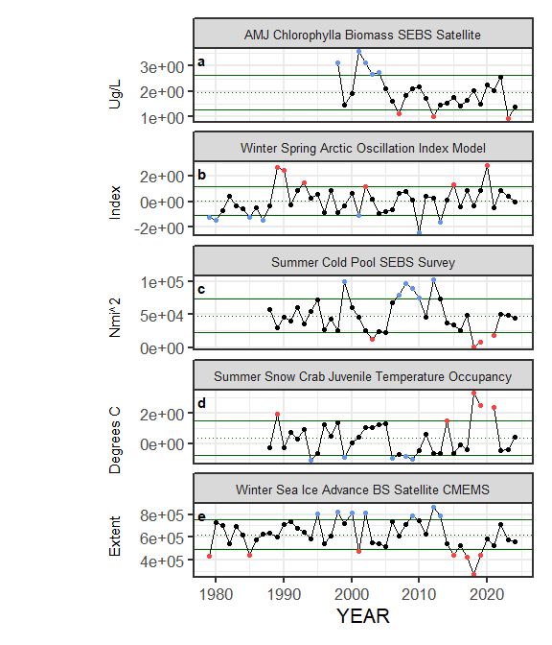

##### Figure ??. Selected ecosystem indicators for Snow Crab with time series ranging from 1977 – present. Upper and lower solid green horizontal lines are plus and minus one standard deviation of the time series mean. Dotted green horizontal line is the mean of the time series.

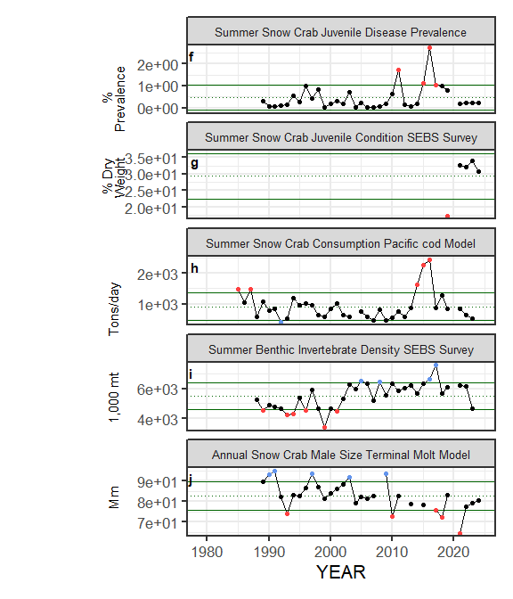

##### Figure ??. Selected ecosystem indicators for Snow Crab with time series ranging from 1977 – present. Upper and lower solid green horizontal lines are plus and minus one standard deviation of the time series mean. Dotted green horizontal line is the mean of the time series.

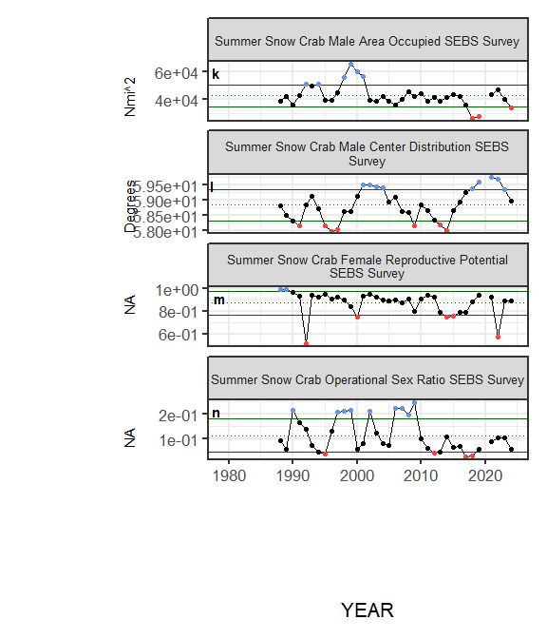

##### Figure ??. Selected ecosystem indicators for Snow Crab with time series ranging from 1977 – present. Upper and lower solid green horizontal lines are plus and minus one standard deviation of the time series mean. Dotted green horizontal line is the mean of the time series.

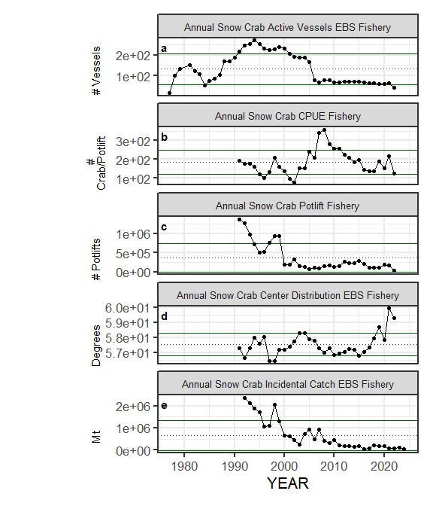

##### Figure ??. Selected socioeconomic indicators for Snow Crab with time series ranging from 1977 – present. Upper and lower solid green horizontal lines are plus and minus one standard deviation of the time series mean. Dotted green horizontal line is the mean of the time series.

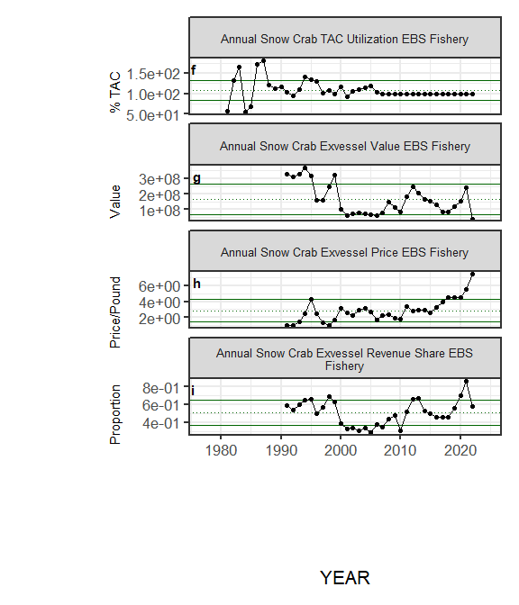

##### Figure ??. Selected socioeconomic indicators for Snow Crab with time series ranging from 1977 – present. Upper and lower solid green horizontal lines are plus and minus one standard deviation of the time series mean. Dotted green horizontal line is the mean of the time series.

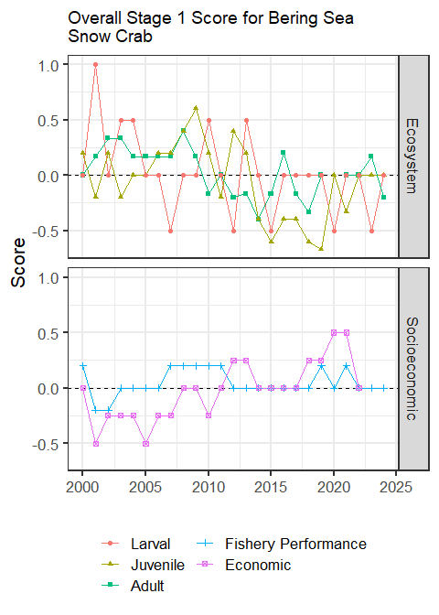

##### Figure 7. Simple traffic light score for overall ecosystem and socioeconomic categories from 2000 to present.



##### Figure 8. Bayesian adaptive sampling output showing (a) standardized covariates prior to subsetting and (b) the mean relationship and uncertainty (95% confidence intervals) with log Snow Crab recruitment, in each estimated effect (left bottom graph), and marginal inclusion probabilities (right bottom graph) for each predictor variable of the subsetted covariate set